THE TRUE STORY
Good afternoon ladies
BLA BLA
BLA BLA
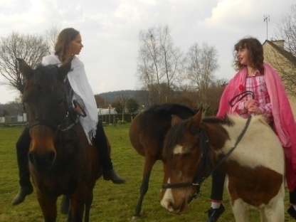  He’s heavy ! | 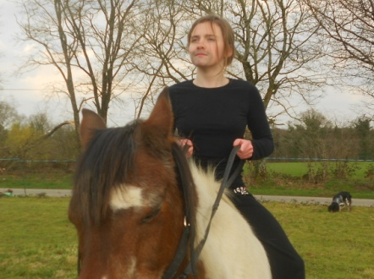
Guinevere and the lady of the lake were going for a ride. | Arthur was on his way to get the sword.
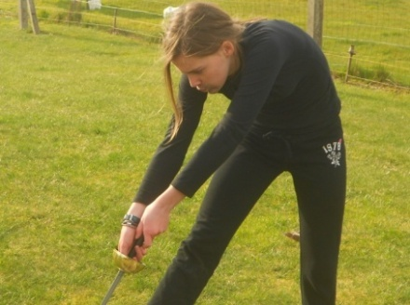
Look at me, I’m the strongest!!!
Arthur bent over to pull the sword from the stone, WHEN… | HIS TROUSERS CRACKED!!!!
Oh dear !  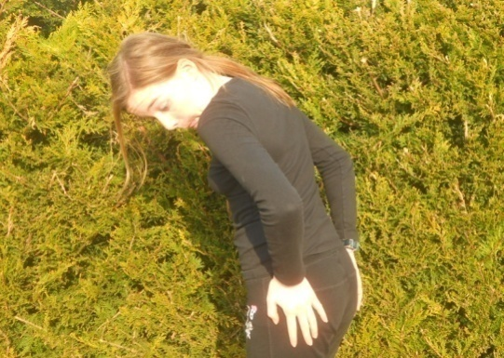 | 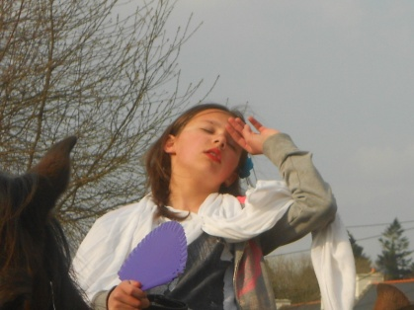  Oh My God !
They saw his pants. | The lady of the lake fainted.

Ouhh, he is good looking

g  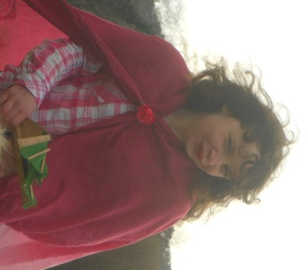 | 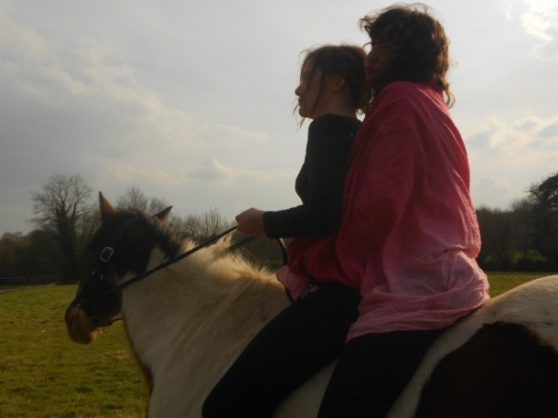
Guinevere was not intimidated by the sight of his pants. | Guinevere and Arthur fell in love and rode off together.

THE END !

