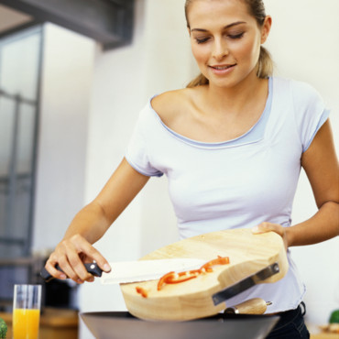 **Change potion**

Ingredients:

-Tongue Of Dog

- 6 Eyes

- 6 Frogs

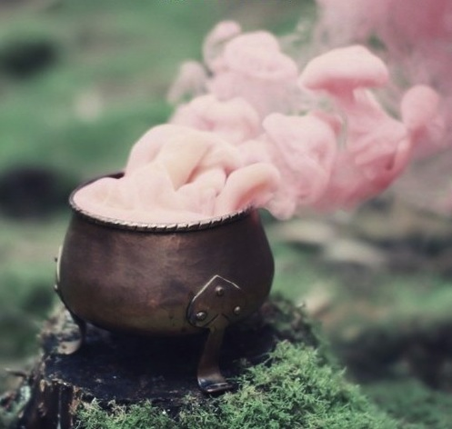- 3 Shoes

- 8 Nose Of Lion

- 4 Snakes

- Blond Hair

- Chips

- 8 Hats

Preparation:

Peel and mix the frogs. Marinate the frogs tongue of dog and stir. Chop the snakes and season. Add the nose of lion. Boil shoes, eyes and blond hair then, blend and hats, chips. Bake the preparation .

[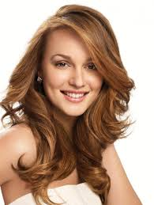](http://www.google.fr/imgres?start=119&biw=1440&bih=805&tbm=isch&tbnid=1NrlWb6ddUL7XM:&imgrefurl=http://www.melty.fr/gossip-girl-le-passe-tumultueux-de-la-belle-galerie-251661-801929.html&docid=U3b7exWbJIGYFM&imgurl=http://media.melty.fr/article-801929-ajust_930/une-jeune-fille-debrouillarde.jpg&w=930&h=1238&ei=K6zXUpyFKY_L0AWG1oDIDQ&zoom=1&iact=rc&dur=981&page=4&ndsp=38&ved=0CD4QrQMwEzhk)[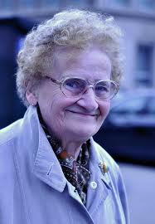](http://www.google.fr/imgres?biw=1440&bih=805&tbm=isch&tbnid=YW4oRrv6awiY2M:&imgrefurl=http://www.pixelistes.com/forum/gallery/amandine-p-a6571/petite-vieille-gay-pride-concours-pixelistes-jpg-p441381.html&docid=K382ZliD4yqnsM&imgurl=http://www.pixelistes.com/forum/gallery/amandine-p-a6571/petite-vieille-gay-pride-concours-pixelistes-jpg-i441381.jpg?view%3Dno_count&w=799&h=1155&ei=aKvXUrbwEsHM0QWEjIEI&zoom=1&iact=rc&dur=1187&page=4&start=35&ndsp=13&ved=0CNkBEK0DMCc) **Before** **After**